**Modern Education Society’s**

**Wadia College of Engineering, Pune**

**Department of Computer Engineering**

|  |
| --- |
| **NAME OF STUDENT: CLASS:** |
| **SEMESTER/YEAR: ROLL NO:** |
| **DATE OF PERFORMANCE: DATE OF SUBMISSION:** |
| **EXAMINED BY: EXPERIMENT NO: 09** |

**TITLE:** Design an application using Angular JS.

**PROBLEM STATEMENT:** Create student registration and login web application using AngularJS

**OBJECTIVES:**

1. Facilitate understanding of the Single Page Applications.

2. Design web pages dynamically and more innovatively using AngularJS with HTML.

3. Write client code using built-in Directives, Filters and expressions.

**OUTCOMES:**

1. Able to design and develop dynamic single page applications.

**PRE-REQUISITES:**

1. Knowledge of JavaScript, HTML, HTML Requests, MySQL

**APPARATUS:**

Computer, Browser, Code Editor, etc.

**QUESTIONS:**

1. What is AngularJS and what are some of its advantages?

2. Explain the difference between a factory and a service in AngularJS.

3. Explain AngularJS built-in directives?

4. How to use AngularJS filters and expression to format and display data?

5. What is What are Single Page Applications (SPA) and Routing in

AngularJS?

**Code:**

**Index.html**

<!DOCTYPE html>

<html>

<head>

    <meta charset="utf-8">

    <title>Assignment-9</title>

    <meta name="viewport" content="width=device-width, initial-scale=1">

    <script src="https://ajax.googleapis.com/ajax/libs/jquery/1.11.2/jquery.min.js"></script>

    <script src="https://ajax.googleapis.com/ajax/libs/angularjs/1.2.26/angular.min.js"></script>

    <link rel="stylesheet" href="https://maxcdn.bootstrapcdn.com/bootstrap/3.2.0/css/bootstrap.min.css">

    <script src="./app.js"></script>

</head>

<body>

    <div ng-app="myApp" ng-controller="MainController" class="container" style="width:550px">

        <div style="text-align:center;color:rgb(15, 15, 15);background-color: rgb(202, 226, 248);">

            <h3><b>{{ isLogin ? 'Login Form' : 'Registration Form' }}</b></h3>

        </div>

        <div ng-class="{'hide': !isLogin}">

            <form role="form" class="well">

                <div class="form-group">

                    <label for="email"> Email: </label>

                    <input type="email" id="email" class="form-control" placeholder="Enter Email "

                        ng-model="loginData.email">

                </div>

                <div class="form-group">

                    <label for="password"> Password: </label>

                    <input type="password" id="password" class="form-control" placeholder="Enter Password "

                        ng-model="loginData.password">

                </div>

                <br>

                <input type="button" class="btn btn-primary" ng-click="login()" value="Login">

                <input type="button" class="btn btn-danger" ng-click="reset()" value="Reset">

                <br>

                <a href="#" ng-click="toggleForm()">No Account? Register Here</a>

            </form>

        </div>

        <div ng-class="{'hide': isLogin}">

            <div align="right">

                <a href="#" ng-click="searchUser()">{{ title }}</a>

            </div>

            <form role="form" class="well" ng-hide="ifSearchUser">

                <div class="form-group">

                    <label for="name"> Name: </label>

                    <input type="text" id="name" class="form-control" placeholder="Enter Name "

                        ng-model="newcontact.name">

                </div>

                <div class="form-group">

                    <label for="email"> Email: </label>

                    <input type="email" id="email" class="form-control" placeholder="Enter Email "

                        ng-model="newcontact.email">

                </div>

                <div class="form-group">

                    <label for="password"> Password: </label>

                    <input type="password" id="password" class="form-control" placeholder="Enter Password "

                        ng-model="newcontact.password">

                </div>

                <div class="form-group">

                    <label for="phone"> Phone: </label>

                    <input type="text" id="phone" class="form-control" placeholder="Enter Phone "

                        ng-model="newcontact.phone">

                </div>

                <div class="form-group">

                    <label for="age"> Age: </label>

                    <input type="text" id="age" class="form-control" placeholder="Enter Age " ng-model="newcontact.age">

                </div>

                <br>

                <input type="hidden" ng-model="newcontact.id">

                <input type="button" class="btn btn-primary" ng-click="saveContact()" value="Register">

                <input type="button" class="btn btn-danger" ng-click="reset()" value="Reset">

                <br>

                <a href="#" ng-click="toggleForm()">Already Have Account? Login Here</a>

            </form>

            <div ng-hide="!ifSearchUser">

                <h4><b>Registered Users</b></h4>

                <table ng-if="contacts.length" class="table table-striped table-bordered table-hover">

                    <thead>

                        <tr class="info">

                            <th>Name</th>

                            <th>Email</th>

                            <th>Phone</th>

                            <th>Age</th>

                            <th>Action</th>

                        </tr>

                    </thead>

                    <tbody>

                        <tr ng-repeat="contact in contacts">

                            <td>{{ contact.name }}</td>

                            <td>{{ contact.email }}</td>

                            <td>{{ contact.phone }}</td>

                            <td>{{ contact.age }}</td>

                            <td>

                                <a href="#" ng-click="edit(contact.id)" role="button" class="btn btn-info">edit</a>

                                &nbsp;

                                <a href="#" ng-click="delete(contact.id)" role="button"

                                    class="btn btn-danger">delete</a>

                            </td>

                        </tr>

                    </tbody>

                </table>

                <div ng-hide="contacts.length > 0">No Users Found</div>

            </div>

        </div>

    </div>

</body>

</html>

**App.js**

var myApp = angular.module("myApp", []);

myApp.service("ContactService", function () {

    var uid = 1;

    var contacts = [

        {

            id: 0,

            name: 'Prathamesh',

            email: 'prathamesh@gmail.com',

            password: '123456',

            phone: '123456789',

            age: '21'

        }

    ];

    // Save Service for saving new contact and saving existing edited contact.

    this.save = function (contact) {

        if (contact.id == null) {

            contact.id = uid++;

            contacts.push(contact);

        } else {

            for (var i in contacts) {

                if (contacts[i].id == contact.id) {

                    contacts[i] = contact;

                }

            }

        }

    };

    // Search for a contact

    this.get = function (id) {

        for (var i in contacts) {

            if (contacts[i].id == id) {

                return contacts[i];

            }

        }

    };

    // Delete a contact

    this.delete = function (id) {

        for (var i in contacts) {

            if (contacts[i].id == id) {

                contacts.splice(i, 1);

            }

        }

    };

    // Show all contacts

    this.list = function () {

        return contacts;

    };

});

myApp.controller("MainController", function ($scope, ContactService) {

    $scope.isLogin = true;

    $scope.contacts = ContactService.list();

    $scope.loginData = {};

    $scope.ifSearchUser = false;

    $scope.title = "List of Users";

    $scope.toggleForm = function () {

        $scope.isLogin = !$scope.isLogin;

    };

    $scope.login = function () {

        const foundUser = $scope.contacts.find(

            user => user.email === $scope.loginData.email && user.password === $scope.loginData.password // Use simple comparison for now

        );

        if (foundUser) {

            localStorage.setItem('currentUser', JSON.stringify(foundUser));

            $scope.isLogin = false;

            alert("Login successful!");

        } else {

            alert("Invalid email or password.");

        }

    };

    $scope.logout = function () {

        localStorage.removeItem('currentUser');

        $scope.isLogin = true;

        alert("Logout successful!");

    }

    $scope.reset = function () {

        $scope.newcontact = {};

    };

    $scope.saveContact = function () {

        if (!$scope.newcontact || !$scope.newcontact.name || !$scope.newcontact.email || !$scope.newcontact.password) {

            alert("Please fill in all required fields.");

            return;

        }

        ContactService.save($scope.newcontact);

        $scope.newcontact = {};

    };

    $scope.delete = function (id) {

        ContactService.delete(id);

        if ($scope.newcontact != undefined && $scope.newcontact.id == id) {

            $scope.newcontact = {};

        }

    };

    $scope.edit = function (id) {

        $scope.newcontact = angular.copy(ContactService.get(id));

    };

    $scope.searchUser = function () {

        $scope.ifSearchUser = !$scope.ifSearchUser;

        $scope.title = $scope.ifSearchUser ? "Back" : "List of Users";

    };

    var contacts = ContactService.list(); // Define contacts variable

    $scope.loginData = {};

    $scope.login = function () {

        const foundUser = contacts.find(

            user => user.email === $scope.loginData.email && user.password === $scope.loginData.password // Use simple comparison for now

        );

        if (foundUser) {

            localStorage.setItem('currentUser', JSON.stringify(foundUser));

            $scope.isLogin = false;

            alert("Login successful!");

        } else {

            alert("Invalid email or password.");

        }

    };

    $scope.logout = function () {

        localStorage.removeItem('currentUser');

        $scope.isLogin = true;

        alert("Logout successful!");

    }

});

**Output:**

1. Registration Form

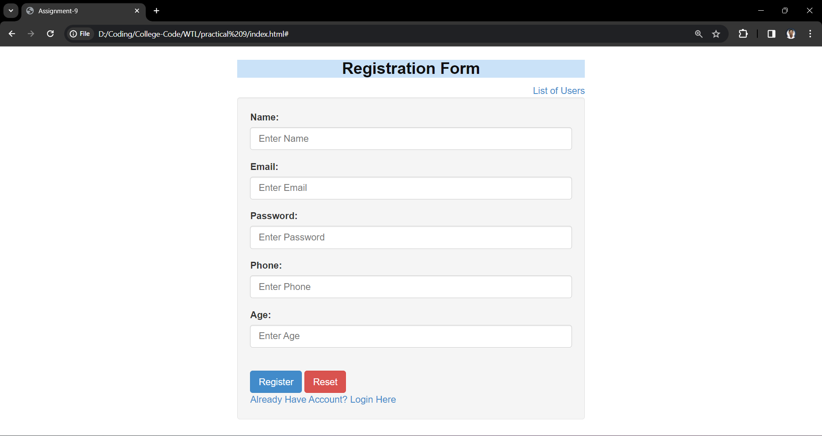

1. List Of Registered Users

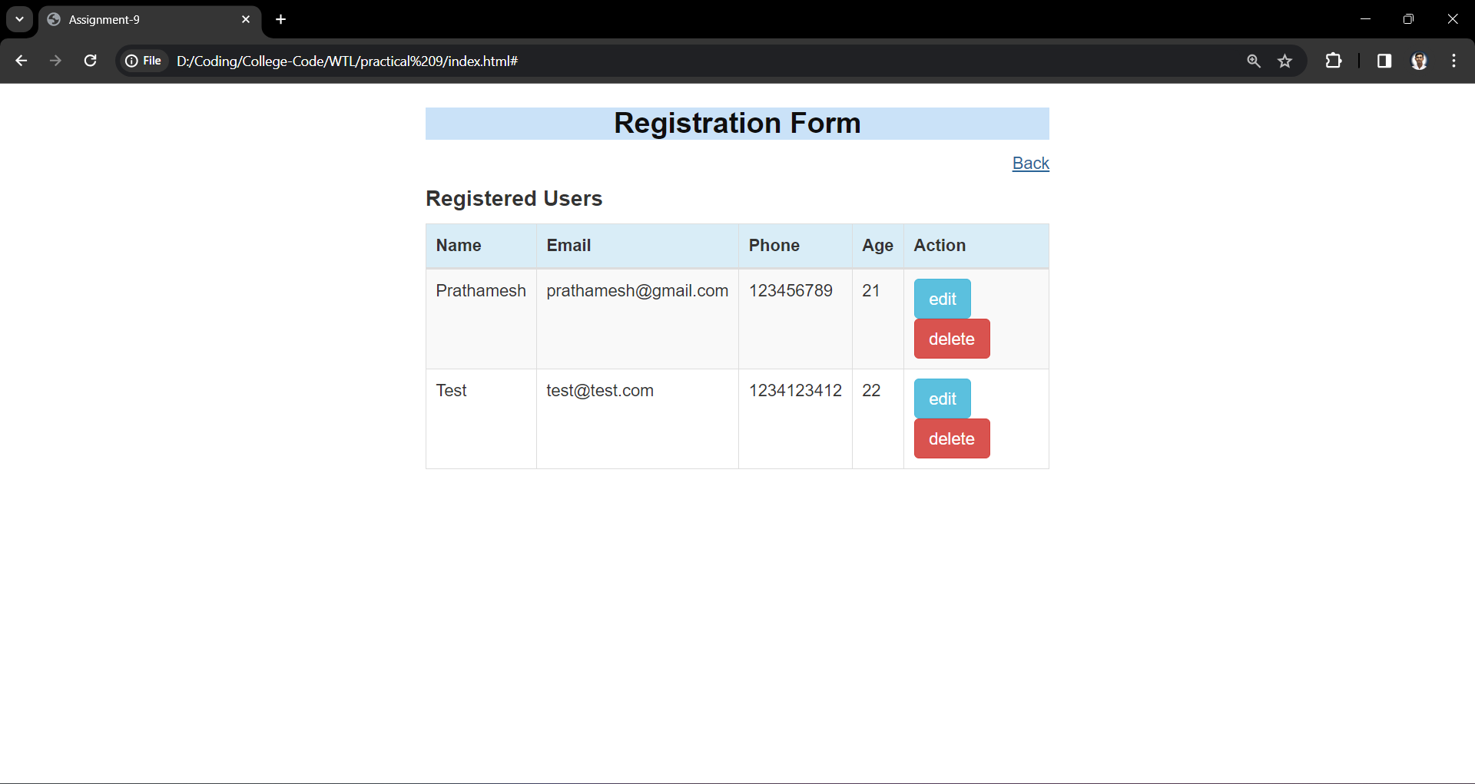

1. Login Form

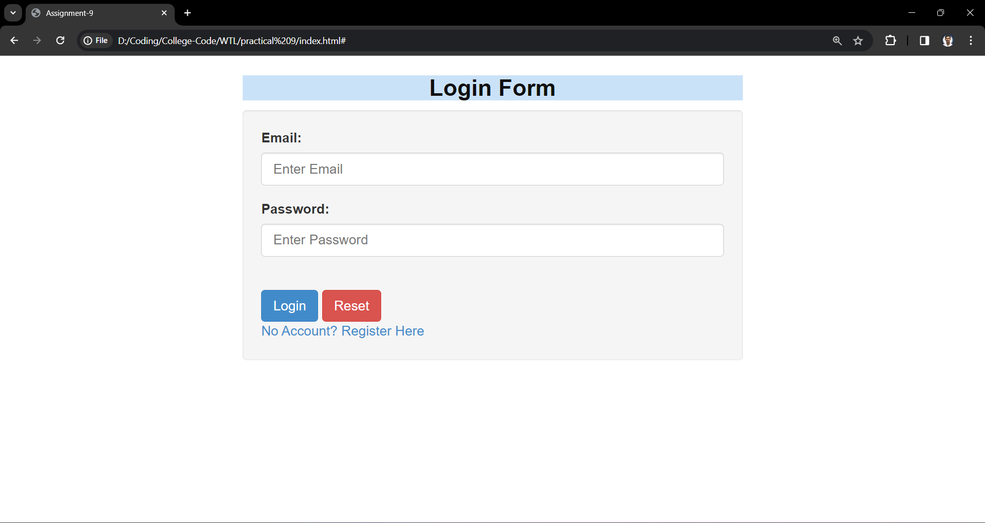

1. Login Success

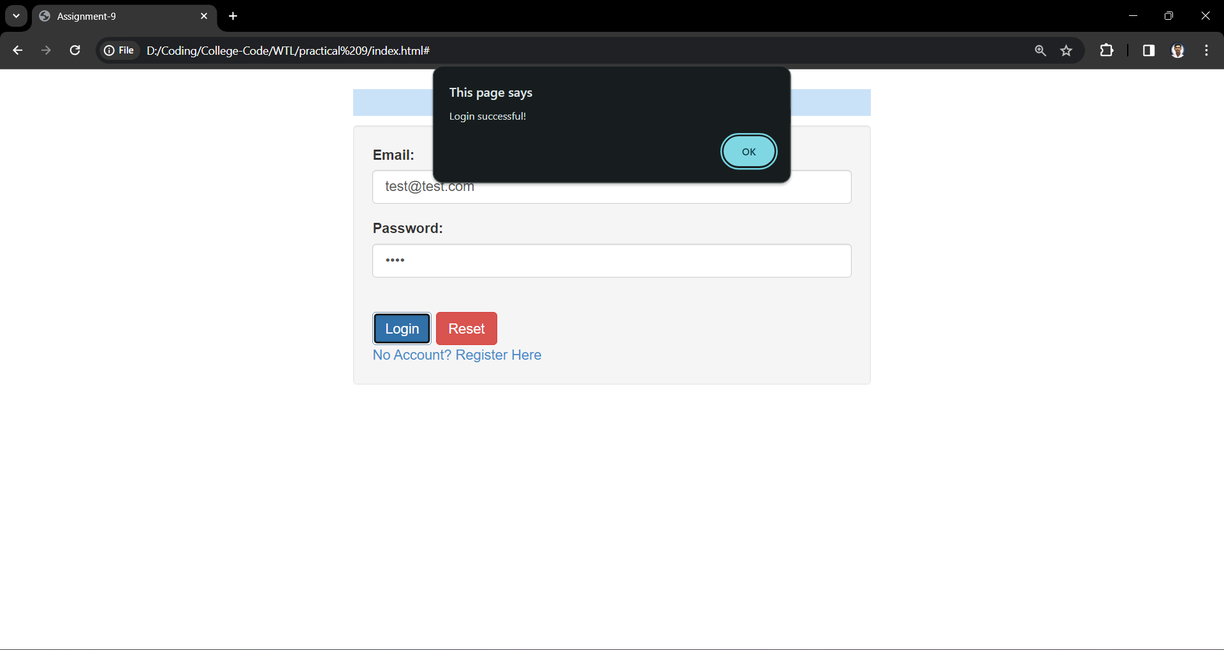

1. Login Failed

